# Iteration 5 – Development log

Iteration 5 will be about developing the static elements of the website. This will mean informational pages, service information, etc.

To do this, all I must do is write lots of information and use a combination of HTML elements to display it nicely for the user. Then, I will use Flask to setup routes for each page.

I started with the “About green energy” page.

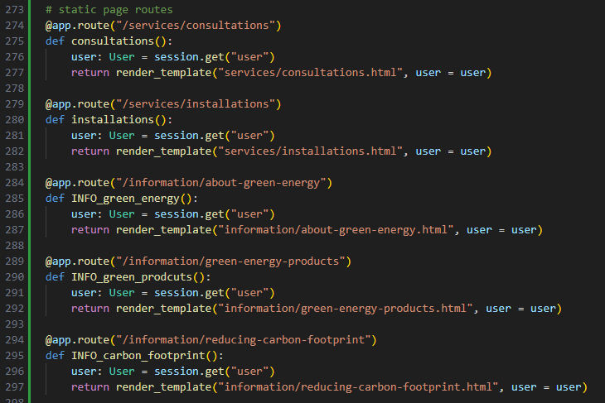

Now I will add the content to each page.

